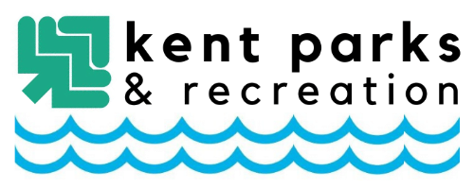

Kent Parks & Recreation Partnership Application Form
This form is an application form and does not guarantee the acceptance of a partnership from the City of Kent Parks & Recreation Department. Please submit completed forms or questions to oliver.wuensch@kentohio.gov or to our Office located at 497 Middlebury Road, Kent, OH 44240. If your application is accepted, you will receive a Partnership Agreement through the email address listed below.
Applicant Information
Partner Organization: Organization’s Name Here
Address: Address Here
Contact Name: Contact Name Here Contact Phone: Contact Phone Number Here
Contact Email: Contact Email Here
Partnership Opportunities
Please select which partnership opportunity you or your organization is interested in below.
☐ Youth Baseball & Softball Presenting Partner - $2000.00
☐ Tee Ball/Coach Pitch Team Partner - $300.00
☐ 7U-12U Youth Baseball Team Partner - $300.00
☐ 7U-12U Youth Softball Team Partner - $300.00
☐ Youth Football & Cheer Team Partner (Only 5 available) - $500.00
☐ Kent Youth Soccer Presenting Partner - $2000.00
☐ Adult Easter Egg Scramble Presenting Partner - $2500.00
☐ Youth Easter Egg Hunt Partner - $500.00
☐ Portage Open Tennis Tournament Presenting Partner - $750.00
Art in the Park Partnership Opportunities
☐ Presenting Partner (Only 1 Available) - $4000.00 ☐ Main Stage Partner - $1000.00
☐ Backwoods Stage Partner - $750.00 ☐ Young at Art Station Partner - $300.00
☐ Youth Artist Partner (Only 1 Available) - $500.00

FOR OFFICE USE ONLY
Date Received: _____________________ Received By: _____________________________
Reviewed Date: ____________________ Accepted/Denied: _________________________

